**ASSIGNMENT 2**

**Use Case Diagrams of Car Sale System**

Melisa Kamacı

Begüm Akdeniz

İrem Tamay

Tamer Alkım Tokuç

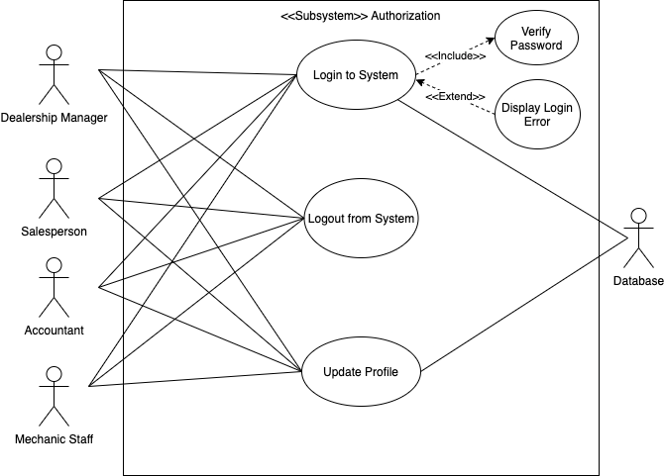

|  |  |
| --- | --- |
| Use Case | Login to System |
| Actor | Dealership Manager  Salesperson  Accountant  Mechanic Staff  Database |
| Description | Login to Systemallows dealership managers, salespeople, accountants, and mechanic staff to access their profiles to use the system according to their privileges. Since usernames and passwords are stored in the database, each time a user logs in to the system, verification of passwords is done by info taken from the database. |

|  |  |
| --- | --- |
| Use Case | Logout from System |
| Actor | Dealership Manager  Salesperson  Accountant  Mechanic Staff |
| Description | Logout from Systemallows dealership managers, salespeople, accountants, and mechanic staff to exit the system to avoid unauthorized operations. |

|  |  |
| --- | --- |
| Use Case | Update Profile |
| Actor | Dealership Manager  Salesperson  Accountant  Mechanic Staff  Database |
| Description | Update Profileallows users to change their profile information which consists of personal data, position, and statistics about the user. Changing account passwords can also be done from this section. All the information regarding the users is held in the database. Every interaction with the profile requires a connection to the database. |

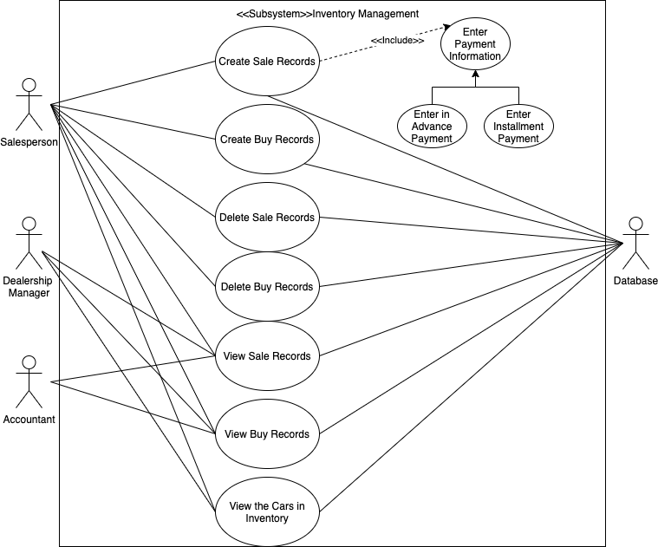

|  |  |
| --- | --- |
| Use Case | Create Sale Records |
| Actor | Salesperson  Database |
| Description | After the sale process is done between customers and dealership, the salesperson initiates this use case. The sale record consists of necessary customer information, properties of the car, and process details including payment information. Payment can be done in advance or by installment. All sale records are kept in the database, therefore connection to the database is essential. |

|  |  |
| --- | --- |
| Use Case | Create Buy Records |
| Actor | Salesperson  Database |
| Description | After buying the second-hand car from the seller, the salesperson initiates this use case. Buy record consists of necessary seller information, properties of the second-hand car, and process details including payment done to the seller. All buy records are kept in the database, therefore connection to the database is essential. |

|  |  |
| --- | --- |
| Use Case | Delete Sale Records |
| Actor | Salesperson  Database |
| Description | In case of accidental entries, disagreement between sides, and other unexpected scenarios, sale records may need to be deleted from the system. The salesperson initiates this use case if necessary. Since all sale records are kept in the database, connection to the database is essential to delete them. |

|  |  |
| --- | --- |
| Use Case | Delete Buy Records |
| Actor | Salesperson  Database |
| Description | In case of accidental entries, disagreement between sides, and other unexpected scenarios, buy records may need to be deleted from the system. The salesperson initiates this use case if necessary. Since all buy records are kept in the database, connection to the database is needed to be able to delete the records. |

|  |  |
| --- | --- |
| Use Case | View Sale Records |
| Actor | Salesperson  Dealership Manager  Accountant  Database |
| Description | After the salesperson enters the log of sale, the manager, accountant, and salesperson may need to check records of sales. Manager may want to keep track of sales, personnel performances, and overall statistics. Similarly, the accountant may need to check records to manage financial operations such as calculation of PNL and taxes. All sale records are kept in the database; therefore, a database connection is needed. |

|  |  |
| --- | --- |
| Use Case | View Buy Records |
| Actor | Salesperson  Dealership Manager  Accountant  Database |
| Description | After the salesperson enters the log of buy, the manager, accountant, and salesperson may need to check records of bought cars. Manager may want to view recently bought cars for management purposes. Similarly, the accountant may need to check records to manage financial operations such as calculation of PNL and taxes. All buy records are kept in the database, therefore connection to the database is necessary. |

|  |  |
| --- | --- |
| Use Case | View the Cars in Inventory |
| Actor | Salesperson  Dealership Manager  Database |
| Description | To show available cars to the customers, the salesperson must initiate this use case. Search results can be filtered according to the preferences of the customers. The dealership manager can arrange plans regarding the current situation of the inventory. All the information about the cars in the inventory is kept in the database, therefore connection to the database is required. |

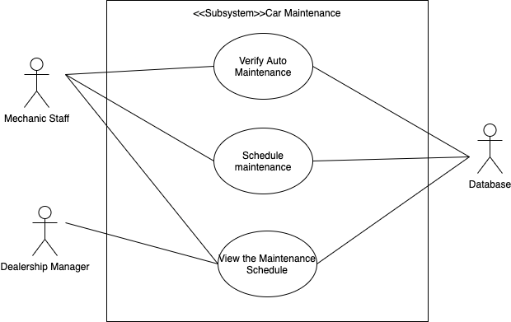

|  |  |
| --- | --- |
| Use Case | Verify Auto Maintenance |
| Actor | Mechanic Staff  Database |
| Description | Since every car needs periodic maintenance, mechanic staff performs maintenance on cars and indicates this information. Because the database stores the maintenance information for each automobile in the inventory, a database connection is requested. |

|  |  |
| --- | --- |
| Use Case | Schedule Maintenance |
| Actor | Mechanic Staff  Database |
| Description | To keep track of maintained cars, mechanic staff can create a maintenance schedule. The records will consist of car details, date and time of the procedure, operations that are done on the car, and the name of the personnel who performed the maintenance. Schedules are held in the database. |

|  |  |
| --- | --- |
| Use Case | View the Maintenance Schedule |
| Actor | Mechanic Staff  Dealership Manager  Database |
| Description | To keep track of maintained cars, the performance of the staff and cars which needs to be maintained, the manager can access to the schedule. Mechanic staff can view the schedule to organize the necessary technical procedures. A database connection is required to perform this use case. |